

AP® Physics C
1990 Free response Questions

The materials included in these files are intended for use by AP teachers for course and exam preparation in the classroom; permission for any other use must be sought from the Advanced Placement Program®. Teachers may reproduce them, in whole or in part, in limited quantities, for face-to-face teaching purposes but may not mass distribute the materials, electronically or otherwise. These materials and any copies made of them may not be resold, and the copyright notices must be retained as they appear here. This permission does not apply to any third-party copyrights contained herein.

These materials were produced by Educational Testing Service® (ETS®), which develops and administers the examinations of the Advanced Placement
Program for the College Board. The College Board and Educational Testing Service (ETS) are dedicated to the principle of equal opportunity, and their
programs, services, and employment policies are guided by that principle.

The College Board is a national nonprofit membership association dedicated to preparing, inspiring, and connecting students to college and opportunity.
Founded in 1900, the association is composed of more than 4,200 schools, colleges, universities, and other educational organizations. Each year, the
College Board serves over three million students and their parents, 22,000 high schools, and 3,500 colleges, through major programs and services in
college admission, guidance, assessment, financial aid, enrollment, and teaching and learning. Among its best-known programs are the SAT®, the
PSAT/NMSQT®, and the Advanced Placement Program® (AP®). The College Board is committed to the principles of equity and
excellence, and that commitment is embodied in all of its programs, services, activities, and concerns.

APIEL is a trademark owned by the College Entrance Examination Board. PSAT/NMSQT is a registered trademark jointly owned by the College Entrance Examination Board and the National Merit Scholarship Corporation. Educational Testing Service and ETS are registered trademarks of Educational Testing Service.
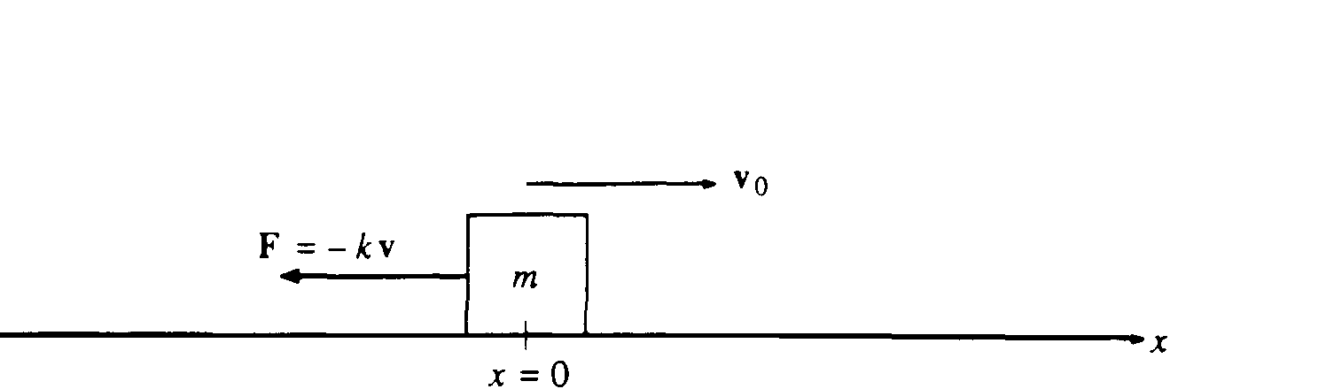

1990M1. An object of mass m moving along the x-axis with velocity v is slowed by a force F = -kv, where k is a constant. At time t = 0, the object has velocity v_{o} at position x = 0, as shown above.
a. What is the initial acceleration (magnitude and direction) produced by the resistance force?
b. Derive an equation for the object's velocity as a function of time t, and sketch this function on the axes below. Let a velocity directed to the right be considered positive.
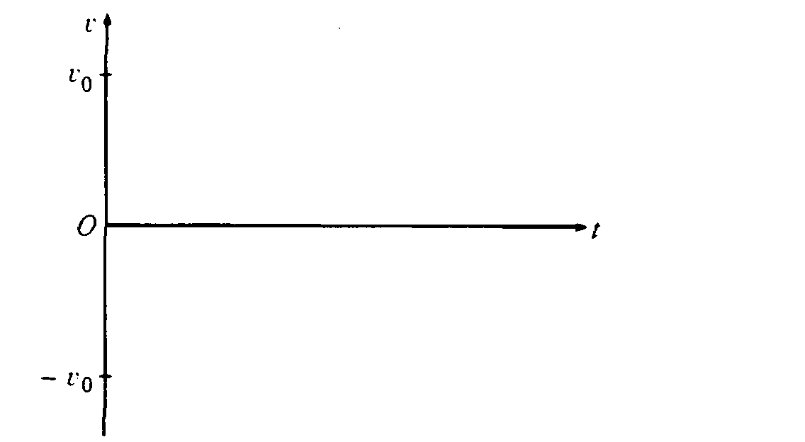
c. Derive an equation for the distance the object travels as a function of time t and sketch this function on the axes below.
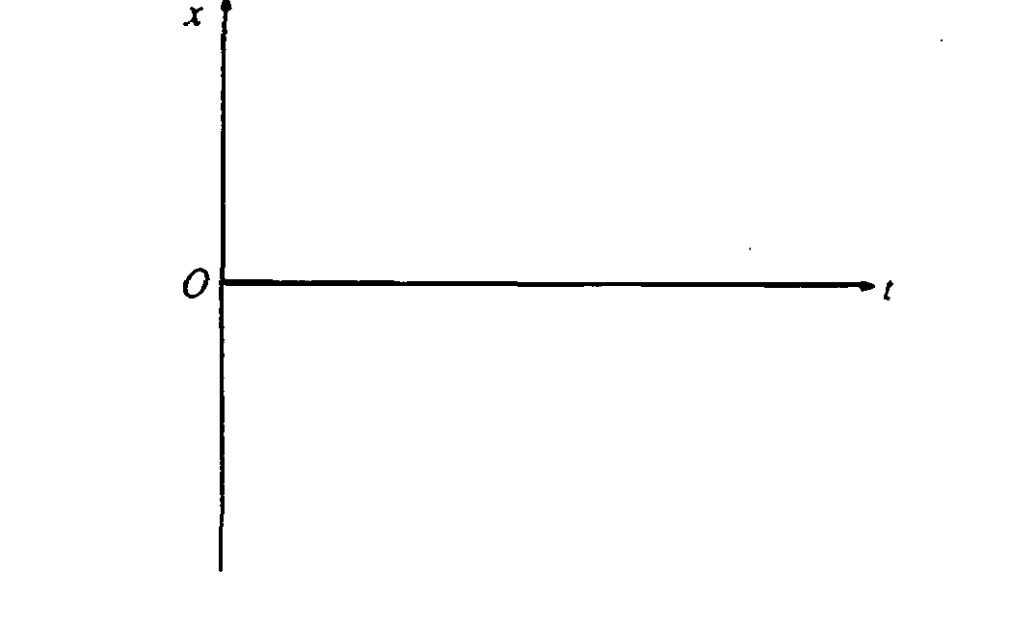
d. Determine the distance the object travels from t = 0 to t = ∞.
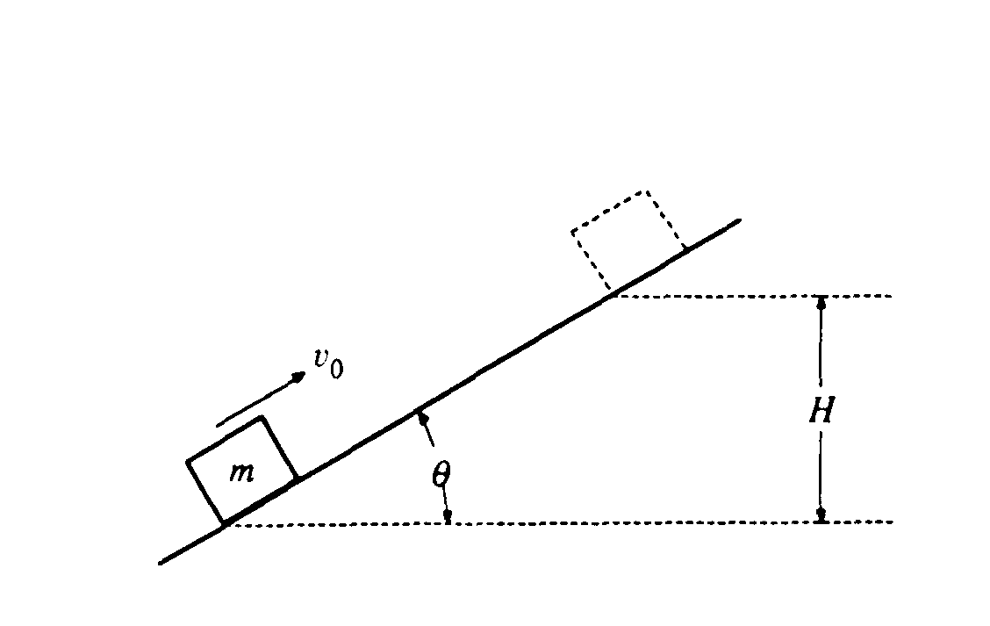
1990M2. A block of mass m slides up the incline shown above with an initial speed v_{O} in the position shown.
a. If the incline is frictionless, determine the maximum height H to which the block will rise, in terms of the given quantities and appropriate constants.
b. If the incline is rough with coefficient of sliding friction μ, determine the maximum height to which the block will rise in terms of H and the given quantities.
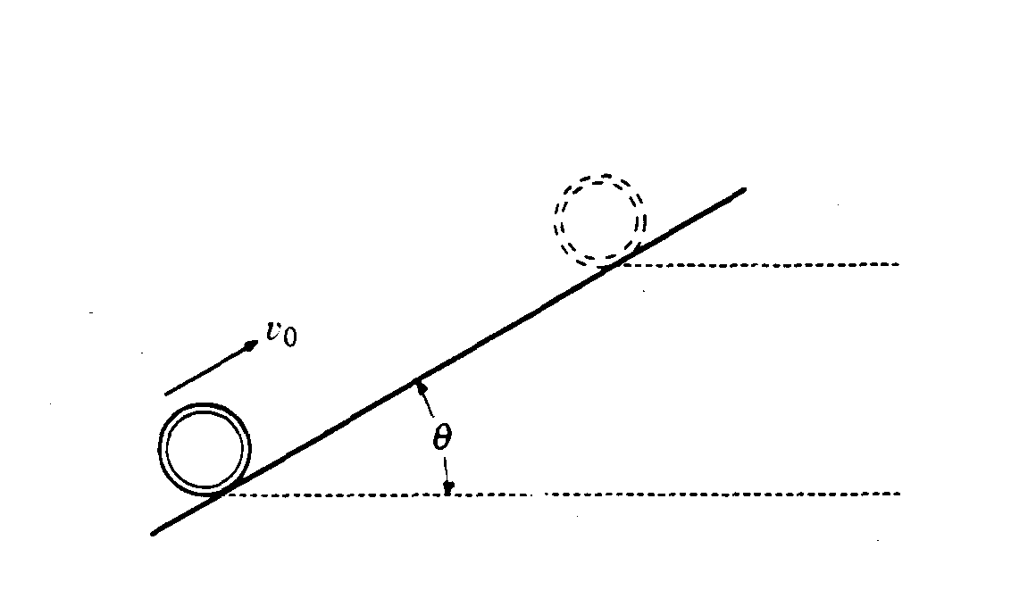
A thin hoop of mass m and radius R moves up the incline shown above with an initial speed v_{O} in the position shown.
c. If the incline is rough and the hoop rolls up the incline without slipping, determine the maximum height to which the hoop will rise in terms of H and the given quantities.
d. If the incline is frictionless, determine the maximum height to which the hoop will rise in terms of H and the given quantities.
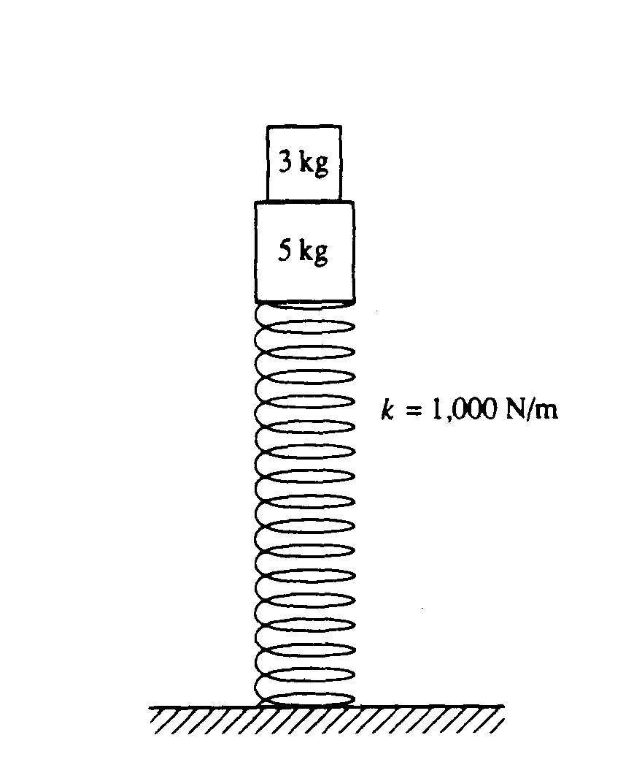
1990M3. A 5-kilogram block is fastened to a vertical spring that has a spring constant of 1,000 newtons per meter. A 3-kilogram block rests on top of the 5-kilogram block, as shown above.
a. When the blocks are at rest, how much is the spring compressed from its original length?

The blocks are now pushed down and released so that they oscillate.
b. Determine the frequency of this oscillation.
c. Determine the magnitude of the maximum acceleration that the blocks can attain and still remain in contact at all times.
d. How far can the spring be compressed beyond the compression in part (a) without causing the blocks to exceed the acceleration value in part (c) ?
e. Determine the maximum speed of the blocks if the spring is compressed the distance found in part (d).
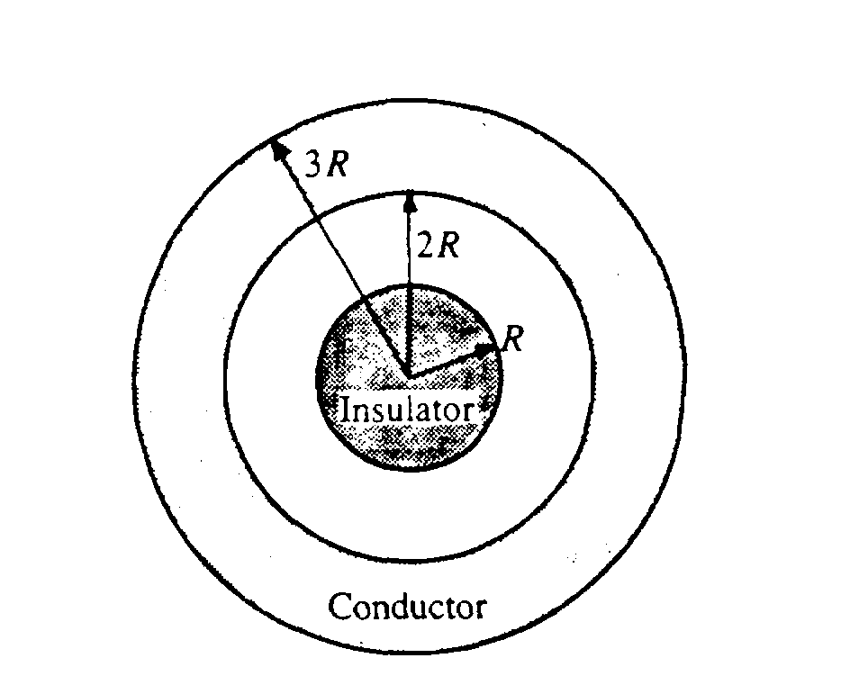
1990E1. A sphere of radius R is surrounded by a concentric spherical shell of inner radius 2R and outer radius 3R, as shown above. The inner sphere is an insulator containing a net charge + Q distributed uniformly throughout its volume. The spherical shell is a conductor containing a net charge + q different from + Q.
Use Gauss's law to determine the electric field for the following values of r, the distance from the center of the insulator.
a. 0 < r < R
b. R < r < 2R
c. 2R < r < 3R

Determine the surface charge density (charge per unit area) on
d. the inside surface of the conducting shell;
e. the outside surface of the conducting shell.
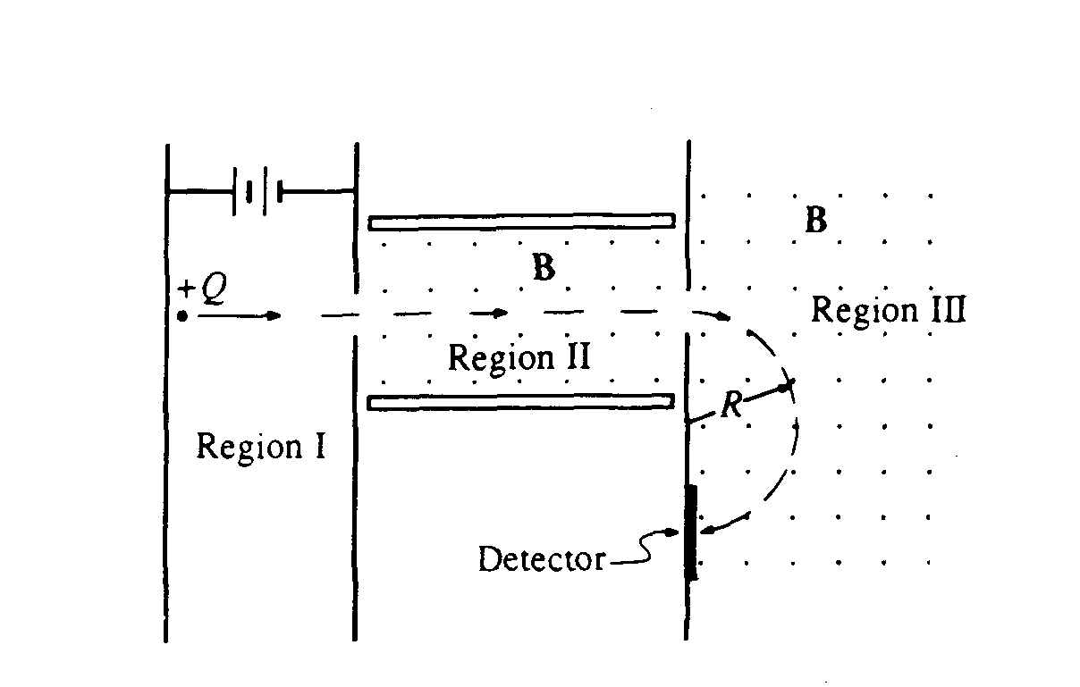
1990E2. In the mass spectrometer shown above, particles having a net charge +Q are accelerated from rest through a potential difference in Region I. They then move in a straight line through Region II, which contains a magnetic field B and an electric field E. Finally, the particles enter Region III, which contains only a magnetic field B, and move in a semicircular path of radius R before striking the detector. The magnetic fields in Regions II and III are uniform, have the same magnitude B, and are directed out of the page as shown.
a. In the figure above. indicate the direction of the electric field necessary for the particles to move in a straight line through Region II.

In terms of any or all the quantities Q, B, E, and R, determine expressions for
b. the speed v of the charged particles as they enter Region III;
c. the mass m of the charged particles;
d. the accelerating potential V in Region I;
e. the acceleration a of the particles in Region III;
f. the time required for the particles to move along the semicircular path in Region III.

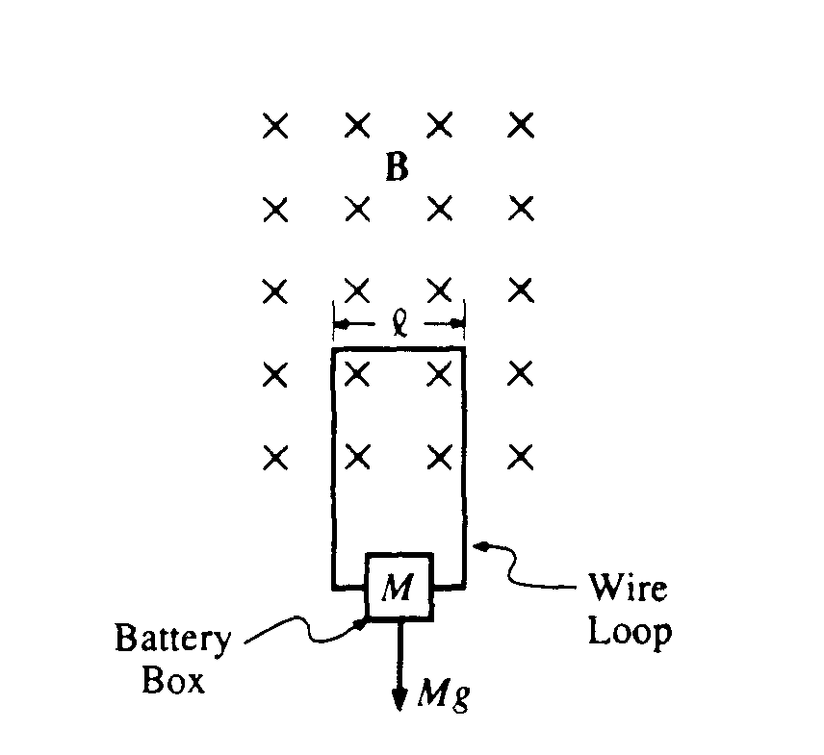
1990E3. A uniform magnetic field of magnitude B is horizontal and directed into the page in a rectangular region of space, as shown above. A light, rigid wire loop, with one side of width l, has current I. The loop is supported by the magnetic field. and hangs vertically, as shown. The wire has resistance R and supports a box that holds a battery to which the wire loop is connected. The total mass of the box and its contents is M.
a. On the following diagram that represents the rigid wire loop, indicate the direction of the current I.

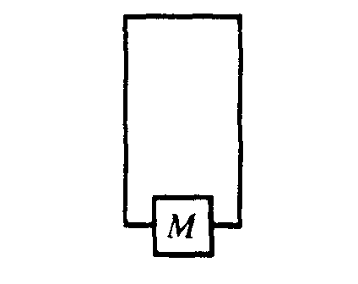
The loop remains at rest. In terms of any or all of the quantities B, l, M, R, and appropriate constants,
determine expressions for
b. the current I in the loop;
c. the emf of the battery, assuming it has negligible internal resistance.

An amount of mass Δm is removed from the box and the loop then moves upward, reaching a terminal speed v in a very short time, before the box reaches the field region. In terms of v and any or all of the original variables, determine expressions for
d. the magnitude of the induced emf;
e. the current I’ in the loop under these new conditions;
f. the amount of mass Δm removed.

